COAL LAB 07
22F - 3441
BSCS - 3D
CODE 1:
[org 0x100]
push word[num]
call factorial
mov word[fac1],ax
jmp last
factorial:
mov bp,sp
mov ax,1
mov cx,[bp+2]
l1:
mul cx
loop l1
ret
last:
mov ax,0x4c00
int 0x21
num:dw 3
fac1:dw 0
OUTPUT:
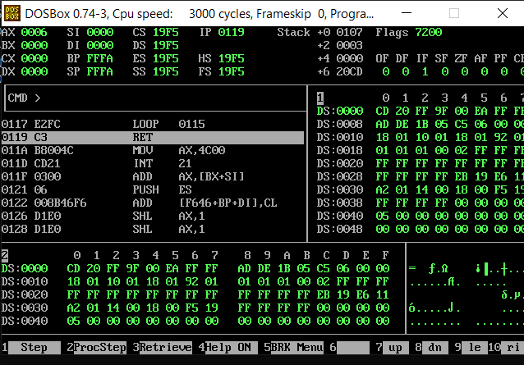
CODE 2:
org 0x100
push array
push word[size]
call sumofarray
mov word[sum],ax
jmp last
sumofarray:
mov bp,sp
mov cx,[bp+2]
mov si,[bp+4]
mov ax,0
mov bx,0
l1:
add ax,[si+bx]
add bx,2
loop l1
last:
mov ax,0x4c00
int 0x21
array:dw 1,2,3,4,5,6,7
size dw 7
sum:dw 0
OUTPUT:
